**Implement Program For Visualization OF Time Series Data**

**EX.No:2**

**DATE: 25/01/2**

**AIM:**

To analyze and visualize electricity production data using various statistical and graphical techniques, including histograms, box plots, scatter plots, bar charts, and heatmaps, for trend analysis and outlier detection.

**ALGORITHM:**

1. Import pandas, matplotlib, and IPython components.
2. Load data from "Plant_1_Generation_Data.csv" into a DataFrame.
3. Explore data: check shape, columns, info, statistics, missing values.
4. Convert 'DATE_TIME' to datetime and set as index.
5. Create a line plot of 'DC_POWER' over time.
6. Display the plot with labels and title.

**CODE:**

from IPython import get_ipython

from IPython.display import display

import pandas as pd

df = pd.read_csv('Plant_1_Generation_Data.csv')

display(df.head())

print("DataFrame Shape:", df.shape)

print("\nColumn Names:", df.columns.tolist())

print("\nDataFrame Info:")

df.info()

print("\nDescriptive Statistics:")

display(df.describe())

print("\nMissing Values per Column:")

print(df.isnull().sum())

df['DATE_TIME'] = pd.to_datetime(df['DATE_TIME'])

df = df.set_index('DATE_TIME')

df['DATE_TIME'] = pd.to_datetime(df['DATE_TIME'], dayfirst=True)

df = df.set_index('DATE_TIME')

print(df.index.is_monotonic_increasing)

print(type(df.index))

import matplotlib.pyplot as plt

df['DC_POWER'].plot(figsize=(12, 6))

plt.xlabel('Time')

plt.ylabel('DC Power')

plt.title('DC Power over Time')

plt.show()

**OUTPUT:**

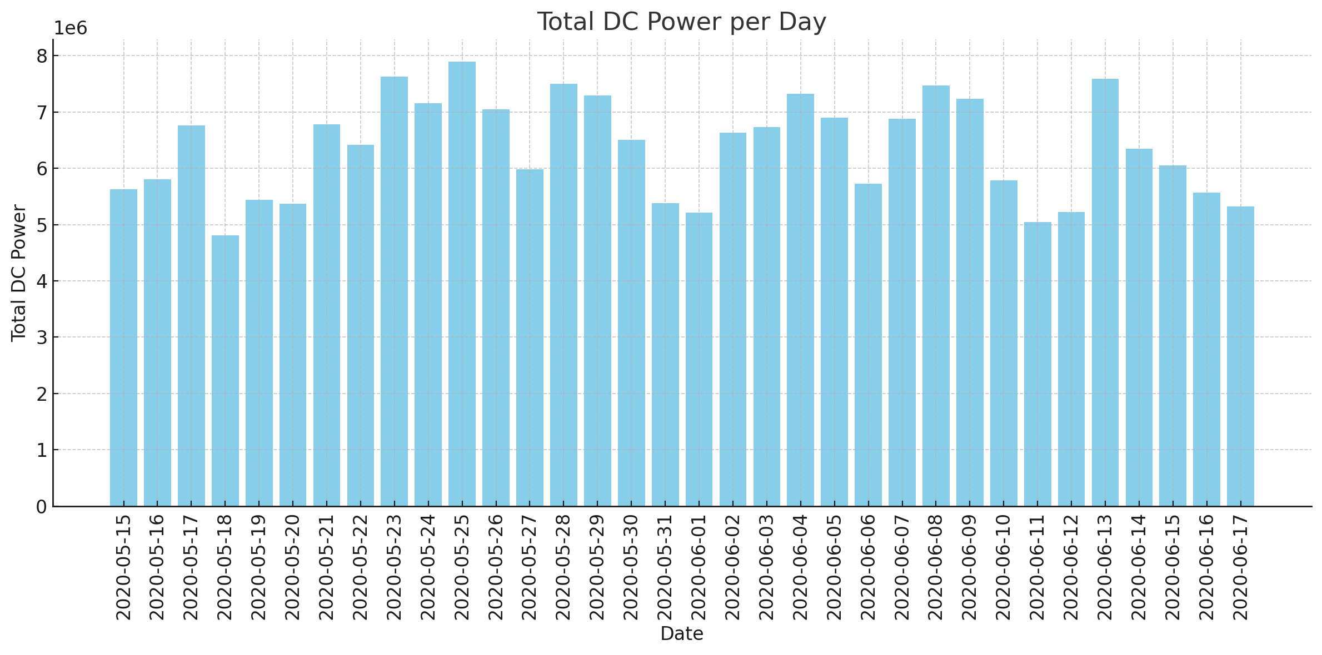

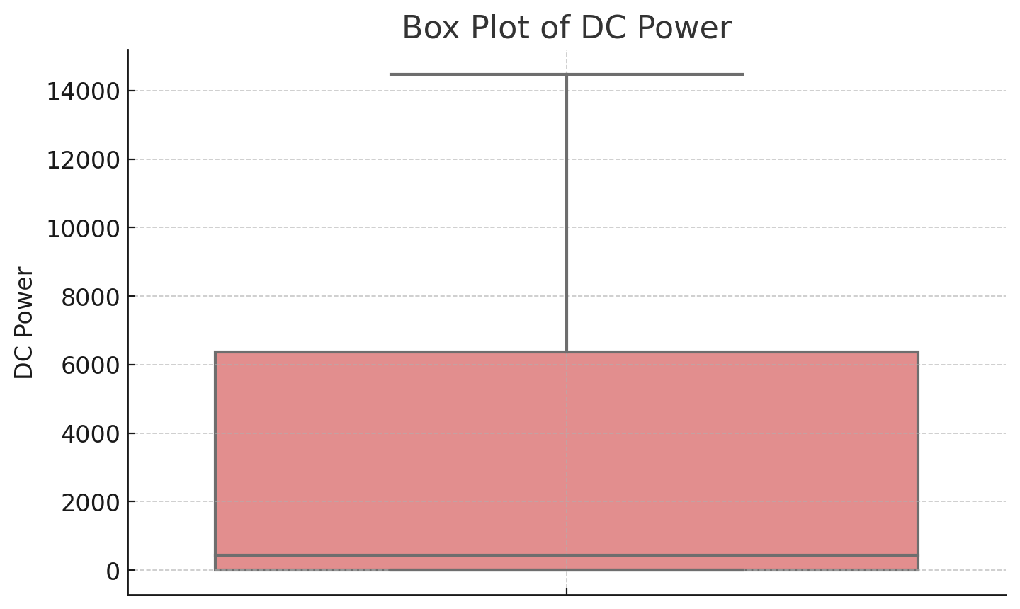

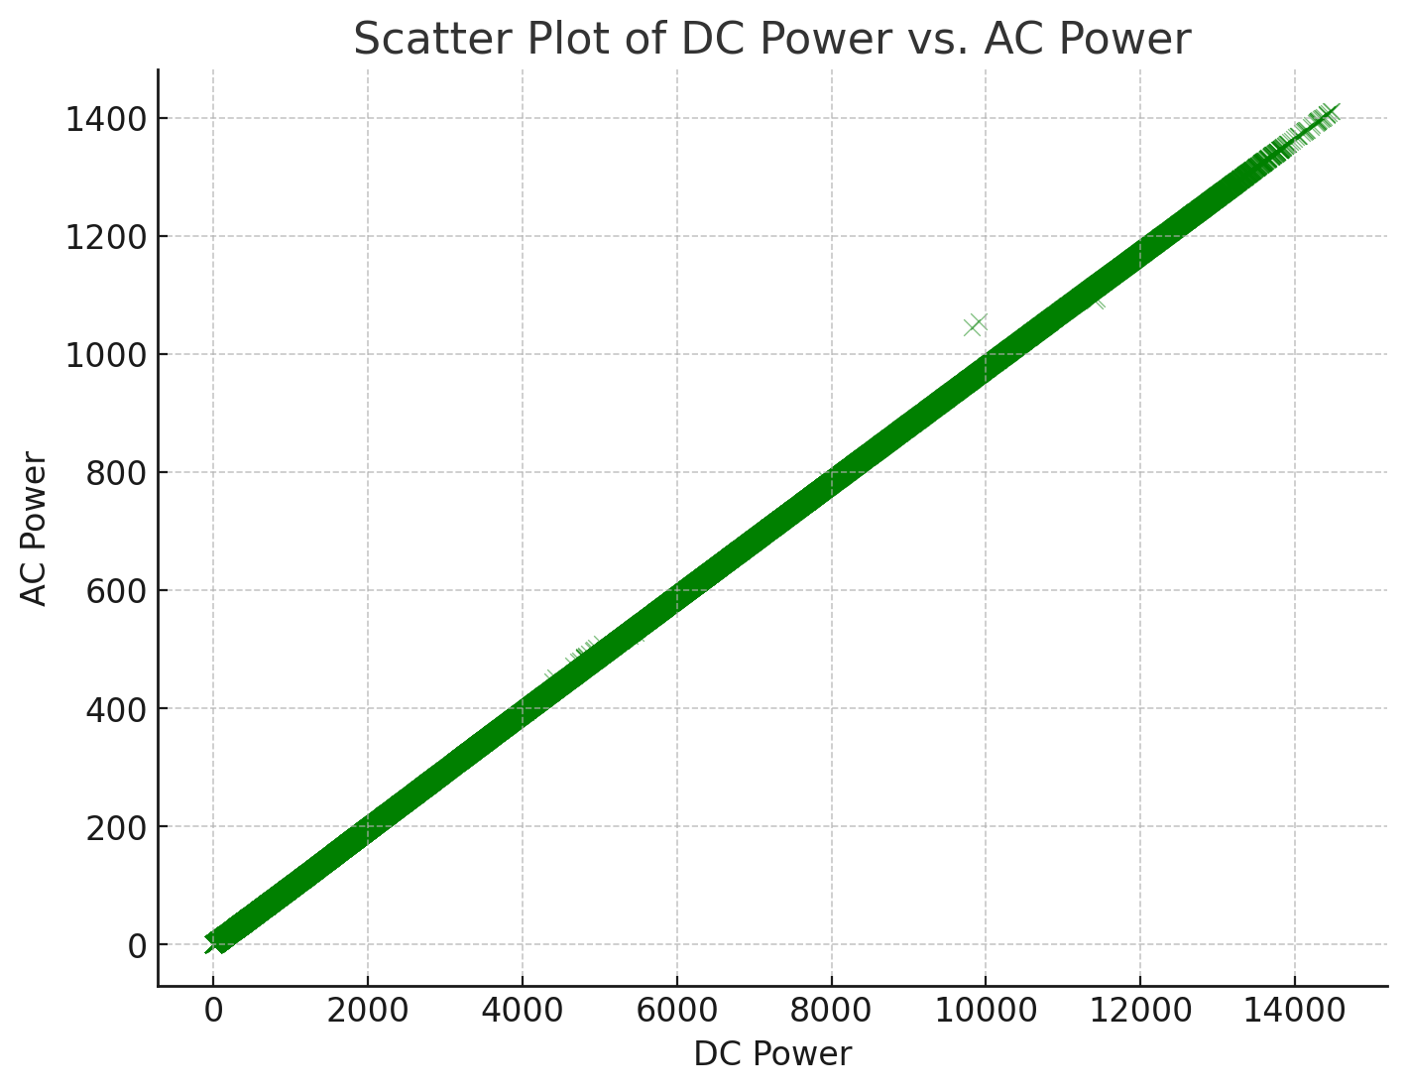

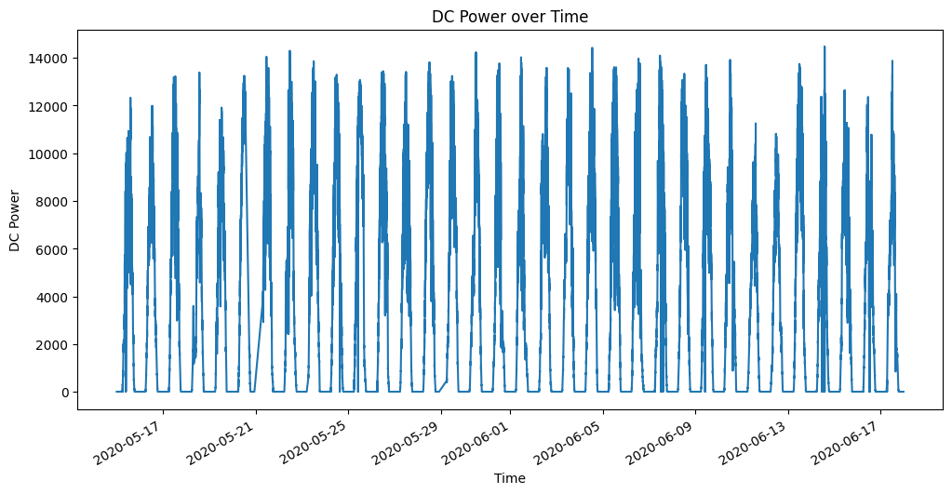

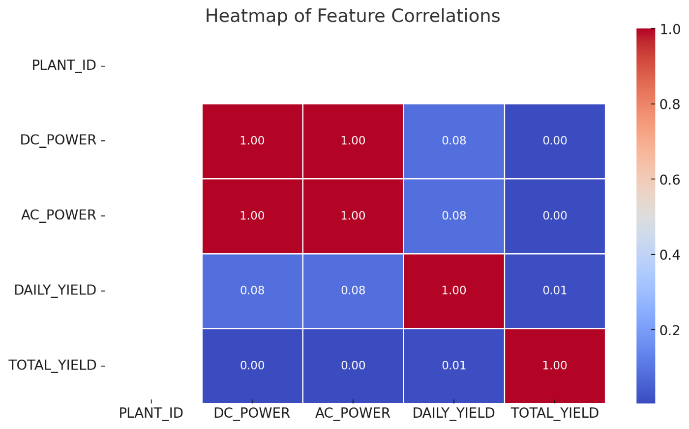

**RESULT:**

Thus the program has been completed and verified successfully.